

CAF Adopt Phase - Scenario 2 - SQL Migration - On Prem to Azure SQL Database

List of Contents
1. Adopt (Migration) 3
1.1 Overview 3
1.1.1 Assess Workloads 3
1.1.2 Deploy Workloads 3
1.1.3 Release Workloads 3
1.2 Assessment 5
1.2.1 Region 7
1.2.2 Migration Toolset 8
1.2.3 Offline vs Online 10
1.3 Deployment 10
1.4 Release 11
1.4.1 Overview 11
1.4.2 Migration Testing 11
1.4.3 Optimization 15
1.4.4 Additional Post Migration Validation and Optimization Documents 17
1.5 Additional Resources 17

Adopt (Migration)
Before you begin migrating your data to the cloud, you should be able to make the following assumptions.
- From the Plan, Ready, and Adopt methodologies, the source data should have been identified and separated into workloads which are manageable to migrate through iterations.
- There should be a landing zone prepared with the adequate configurations to receive the incoming data workloads
A single database is similar to a contained database in SQL Server. You can use either the DTU or vCore pricing model for a single database. Below Links provides the detailed resource limits for single databases in Azure SQL Database using the vCore and DTU purchasing model:
- https://docs.microsoft.com/en-us/azure/azure-sql/database/resource-limits-dtu-single-databases
- https://docs.microsoft.com/en-us/azure/azure-sql/database/resource-limits-vcore-single-databases

Overview
During each iteration of migrating a workload, there are 3 phases which are necessary to maximize performance. This section will specifically discuss the following:
- Assess workloads
- Deploy workloads
- Release workloads

Assess Workloads
Make concrete decisions regarding cost, modernization options, and deployment tools. You should reassure that any assumptions made during the discovery phase on the data characteristics holds to be true; as well as build on top of those decisions to give the most redefined description about that data.

Deploy Workloads
Replicate or improve performance from the source by taking advantage of tools available in the cloud such as:
- Azure Database Migration Services
- Data Migration Assistant

Release Workloads
Once the data workloads have been deployed in the cloud, you should test, optimize, and review the newly deployed workload to ensure the correct data and functionality has been deployed.

Below steps will walk us through the overview of the migration process.
- Consider the maintenance windows that are available to the application and database targeted for migration: If they are critical workloads, they may only be able to go offline for a few minutes at a very specific point in time. Alternatively, a workload may be used for historical reporting purposes and can easily be taken offline most days of the week without impacting end-users. These differences will help decide which migration technique needs to be used.
- Start with low priority databases first: This can help ensure the migration process works and help gauge how long the migration is likely to take when you get to your more critical workloads.
- Fix compatibility issues outlined in Data Migration Assistant: These issues should be fixed during the Transform and Optimize phase, but validate that DMA no longer presents any remaining issues.
- Run a test migration with chosen tool: Before migrating the database, run a test migration of the database to confirm the amount of time the migration will take, and any issues encountered during the migration process.
- Test database for issues: When the test migration completes, perform validation steps to confirm that the data is migrated in full and check for any issues encountered on the Azure SQL platform.
- Repeat issue fixes until the database is fixed: For each issue discovered during testing, find a fix, and then retest. Keep repeating this test-fix cycle until all issues have been found and repaired.
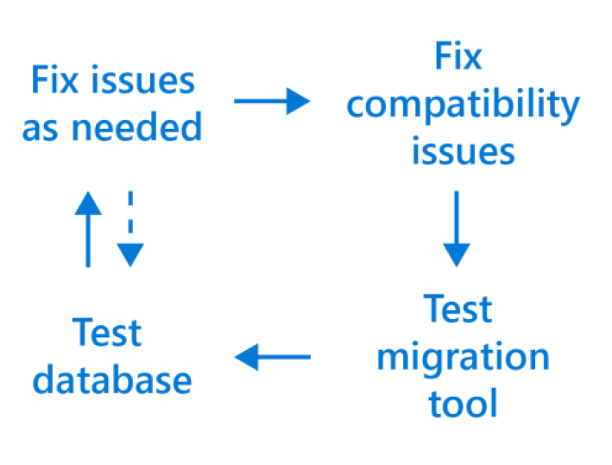
- Re-write third-party applications for the cloud as needed: Third party applications may benefit from the Azure Application Architecture Guide as it discusses older on premises versus cloud architecture models that could help optimize performance and decrease overhead with leaner coding approaches. Each application should be analyzed on a case by case basis to see if a lift and shift or a re-write in necessary.
- Test third-party applications: Confirm that any third-party applications will still function as expected in the cloud as each application is moved, including any dependencies.
- Take old databases and application offline: Remember to take the source database and application offline before starting the migration process to avoid confusion and preserve the original data in case there is a need to refer to them or perform a roll-back.
- Create new disaster recovery and maintenance plans: Take the time to update your disaster recovery plans, as data has now moved locations and is accessed in a different manner. Consider improving disaster recovery plans by utilizing the geo-replication features of Azure to protect data that may previously have been too complex or costly to protect when on-premises. Maintenance plans will also need to be reviewed as Azure now performs many of those maintenance tasks automatically for you in the background, removing the need to perform them manually.
- Use toolsets to give you greater insight into your environment and greatly assist with the migration process: Numerous Microsoft and third-party tools exist that can help keep tabs on your SQL environments both on premises and in the cloud, including:
  - Azure Database Migration Service (DMS) helps track progress of large-scale migrations of data to Azure.
  - Microsoft Operations Management Suite can help monitor and visualize SQL workloads both on-premises and in the cloud, including SQL Server version count, current CPU performance, job successes and failures, and any logged events.
  - Azure SQL Database Intelligent Insights is a tool that uses built-in intelligence to continuously monitor database usage and detect disruptive events that cause poor performance, offering recommendations for improvements that could help with functionality.
- Assess migration tools based on disruption to help lower the risk of database downtime: In the coming sections we’ll look at which migration tools require downtime to complete, and which ones can work in the background while the workload remains online and available.
- Understand your workload requirements as a starting point: Requirements might include storage size, storage throughput, and high availability.
- Create a plan to mitigate risk associated with downtime and compatibility issues: Many of the discussed points in this whitepaper will help to reduce the risk of errors during the migration. Conduct test migrations before doing the final migration by getting to know any errors before getting to more critical workloads and have a rollback plan prepared in case of an emergency.
- Understand feature parity between versions of SQL Server and use assessment tools to mitigate choosing the wrong target option: Tools such as Data Migration Assistant (DMA) will help identify if the source workload is using features unavailable on some platforms in Azure.
- Select non-critical workloads for migration initially: This can help ensure the migration process works and help gauge how long the migration is likely to take when you get to your critical workloads.
- Continually iterate on your migration process: During the first migrations small changes will be found, documentation or processes will need to be created, or unnecessary migration steps will need to be removed. These findings should be fed back into the migration process that you are following to optimize the remaining higher priority migrations.
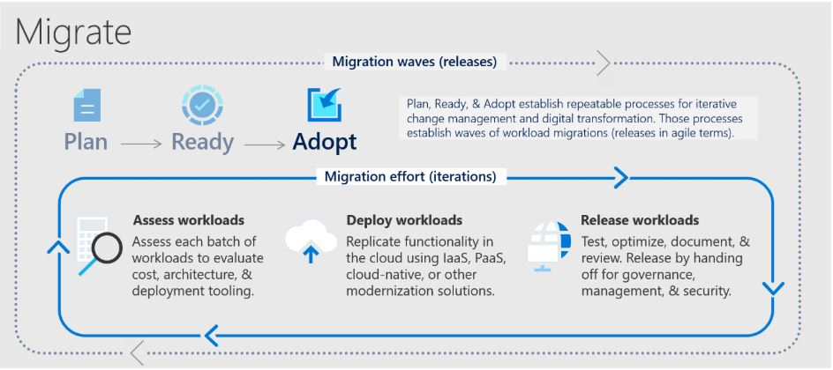

Assessment
When your landing zone for your SQL server data is a Azure SQL Database server, When the data sources have been identified, the next step is to assess on-premises SQL Server instance(s) migrating to Azure SQL database(s) to understand the gaps between the source and target instances. To assess the workload native as well as third party assessment tools are as follows:
Assessment Tools | Features | Unique Benefits
Database Migration Assistant | Data Migration Assistant helps pinpoint potential problems blocking migration. It identifies unsupported features, new features that can benefit you after migration, and the right path for database migration. | DMA is able to discover issues that not only disrupt the migration process, but also those that disrupt the on-premises upgrade process for SQL Server. DMA can also discover the new features that are present in the target SQL platform, and will prove to be beneficial for the database, once the upgrade is done.
Azure Migrate: Server Assessment | Discover and assess on-premises VMware VMs, Hyper-V VMs, and physical servers in preparation for migration to Azure. | It can perform assessment in two ways:  - Assessment based on collected performance data  - Assessment based on on-premises sizing
Unifycloud  (Cloud Recon) | CloudRecon creates a cloud migration strategy and assessment by conducting a deep scan on your IT infrastructure, producing recommendations on which applications should migrate to the Cloud (SaaS, IaaS, or PaaS), and the roadmap behind it. CloudRecon is capable of providing TCO estimates and can validate the move to the cloud. | Automated on-premises infrastructure assessments in minutes, not months.  Automation saves time and expense over arduous manual assessments.  Detailed inventory assessments provide insights to inform your cloud migration strategy.
Cloud Amize | Cloudamize is a cloud computing analytics platform that provides high precision analytics and powerful automation to improve the ease, speed, and accuracy of moving to the cloud. | Cloudamize’s discovery, integrated compatibility reporting, right-sizing, and performance and cost predictions enable customers to understand where SQL updates are required and whether it’s better from a cost-performance optimization standpoint to take the IaaS or PaaS version of SQL migration.

An overview of the steps associated with using DMA to create an assessment follows.
- Open the Data Migration Assistant (DMA), and then begin creating a new assessment project.
- Specify a project name, select SQL Server as the source server type, and then select Azure SQL Database as the target server type.
- Select the type(s) of assessment reports (database compatibility and feature parity) that you want to generate.
  - The SQL Server feature parity category provides a comprehensive set of recommendations, alternative approaches available in Azure, and mitigating steps to help you plan the effort into your migration projects.
  - The Compatibility issues category identifies partially supported or unsupported features that reflect compatibility issues that might block migrating on-premises SQL Server database(s) to an Azure SQL Database. Recommendations are also provided to help you address those issues.
- Specify the source connection details for your SQL Server, connect to the source database, and then start the assessment.
- When the process is complete, review the assessment reports for migration blocking issues and feature parity issues by selecting the specific options. Optionally, assessment results can be uploaded to Azure Migrate to get consolidated view across many on premise SQL Servers. More information here
- Determine the database compatibility level that you want to minimize your efforts after migrating to Azure SQL Database.
- Identify the best Azure SQL Database SKU for your on-premises workload.

For additional detail on this process, see the article Perform a SQL Server migration assessment with Data Migration Assistant. There are also additional target decisions that you will have to make before starting migration phase. Some things worth taking into consideration are:
- In which region you want your target Azure SQL server
- How much downtime is acceptable for your business needs?
We provide more details in the following segments.

Region
Azure SQL Databases can be created in multiple regions around the globe. The below diagram shows the regions available in North America.
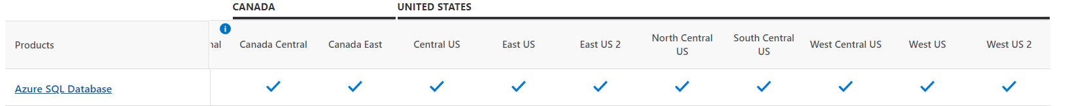
Its recommended to migrate to Azure SQL Database in the same region as the on-prem server. Example: If you have on-prem server in East US, then choose Azure SQL Database in US East. For High Availability (HA) of Azure SQL Database, multi-region deployment is one of the techniques which uses Azure Traffic Manager to failover if the DB fails in one region.

In such a scenario, combined SLA for multiple regions can be calculated as follows.

Let N be the SLA for SQL Database in one region and R be the number of regions where SQL Database is deployed. Combined SLA can be given as = 1 - (Product of Downtime of every region)

Let’s say N = 99.95% for all regions. so, the downtime for all regions will be 0.05%
Combined SLA for 2 regions = (1 - (0.0005 ^ 2)) = 99.999975%
Combined SLA for 4 regions = (1 - (0.0005 ^ 2)) = 99.999999%
So, when we have more regions Combined SLA will increase. Below are the combination of Azure SQL DB deployments option and their promised SLAs.
SLA | Tier | Requirements
99.995% | Business Critical + Premium | Zone Redundant Deployment
99.99% | Business Critical + Premium | N/A
99.99% | General Purpose, Standard, Basic, Hyperscale | 2 or more replicas
99.99% | Hyperscale | 0 replicas

Consider checking Latency before performing multi-region deployment using below links:
- https://cloudpingtest.com/azure
- https://www.azurespeed.com/Azure/Latency

Migration Toolset
There are a number of tools and methods that will help you migrate to Azure SQL DB from SQL Server on-premises. Here is a simple workflow that can help with tool selection:

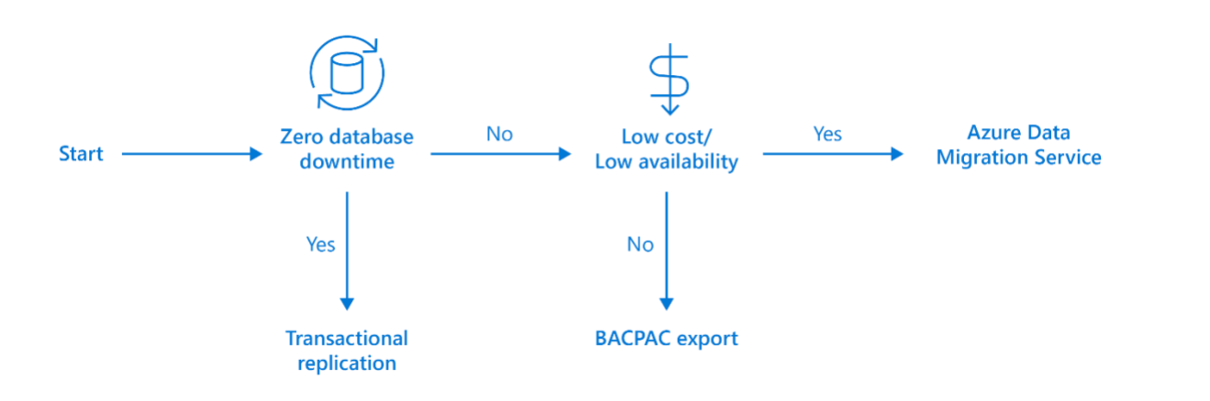
For critical workloads, which can afford zero database downtime, SQL Server Transactional Replication should be used to synchronize all data between on-premises and Azure while keeping the source database online and servicing requests. For general workloads, where small amounts of downtime are acceptable, Azure Data Migration Service can be used to manage the migration process for all these databases.

For all other workloads that can be taken offline at a scheduled time, exporting a BACPAC file containing the data and schema of the source data base and importing this into Azure would be a good fit. Different tools can be used for different needs and no single tool must be used for all database migrations. We will investigate each of these further in the sections to come. Below are details of Data Migration Toolsets
- Azure Data Migration Service (DMS): Azure Data Migration Service supports online (minimal downtime) and offline (one time) migrations at scale to an Azure SQL Database from SQL Server 2005, SQL Server 2008 and SQL Server 2008 R2, SQL Server 2012, SQL Server 2014, SQL Server 2016, and SQL Server 2017. This document will focus mainly on this toolset for migration.
- Migration using data-tier application export/import (BACPAC): You can package on-premises database as DACPAC or BACPAC file and import it into Azure SQL DB as explained here - https://docs.microsoft.com/en-us/azure/sql-database/sql-database-import?tabs=azure-powershell
- Migration using SQL Server Transactional Replication: When you cannot afford to remove your SQL Server database from production while the migration is occurring, you can use SQL Server transactional replication as your migration solution. To use this method, the source database must meet the requirements for transactional replication and be compatible for Azure SQL Database. For more on this method see - https://docs.microsoft.com/en-us/azure/sql-database/sql-database-single-database-migrate#method-2-use-transactional-replication

The following table summarizes the scenarios where each of the migration tools are suited:
Migration Tools | Indicators to look for | Unique Benefits
Database Migration Service (DMS) | Many databases to migrate with moderate maintenance window allowance Large databases (>1TB) | - Supports moving multiple databases concurrently
BACPAC | Small number of ad hoc databases to migrate  Small to medium sized databases (<1TB)  Low availability requirements with relaxed maintenance windows | - Quick and easy with no real set up requirements
Unifycloud (CloudPilot) | CloudPilot analyze applications at the code level to determine cloud readiness and conduct migrations for Cloud-ready applications. | - Demonstrate how the Cloud can lower the cost.  - Reduce the time and expense to migrate applications to the Cloud.  - Create a standard approach to developing and re-mediating applications to run in the Cloud.  - Provide a standard Cloud controls environment for both development and deployment testing.  - Simple App Data Collection  - Cloud Migration Refinement
Cloudamize | The Cloudamize SQL Migration & Modernization Planner eases and optimizes migrating on-premises server databases to Azure. | - Move workloads to Azure with speed and accuracy and ensure cost-performance optimization at the moment applications migrate.
Transactional Replication | Critical database with small or non-existent maintenance window  Large databases (>1TB) | - Smallest possible outage requirements for  - switch over as source database remains online  - and servicing requests during synchronization of  - data
For a walkthrough of the phases of the migration process and detail about the specific tools and services recommended to perform assessment and migration, see the video Overview of the migration journey and the tools/services recommended for performing assessment and migration.

Offline vs Online
When migrating a database via the Azure Database Migration Service, you have the option of migrating offline and online. With offline migration, your application downtime will last for the duration of the migration. On the other hand, with online migration your downtime will be limited to the time to cut over at the end of the migration.

Cost: Azures 2 tiers which determine your migration cost, migration duration, and downtime.
 | Core Quantity | Offline | Online | Cost
Standard | 1 - 4 | Yes | No | Free
Premier (free for the first 6 months) | 4 | Yes | Yes | $0.308 / hour
If minimizing downtime is a priority, the Premier tier is the faster option due to the online migration availability. Otherwise, you can also scale up your Azure SQL Database target instance to the Premium tier SKU during the migration to minimize Azure SQL Database throttle.

Deployment
After you are comfortable with the assessment and satisfied that the selected database is a viable candidate for migration to Azure SQL Database. Using Data Migration Assistant (DMA) to migrate the schema to Azure SQL Database. Before you create a migration project in DMA, be sure that you have already provisioned target Azure SQL database in the region where you want to migrate to. An overview of the steps associated with using DMA to migrate the schema follows.
- Open DMA, and then begin creating a new migration project.
- Specify a project name, select SQL Server as the source server type, and then select Azure SQL Database as the target server type.
- Specify the migration scope as Schema only, and then create the project.
- Specify the source connection details for your SQL Server, and then connect to the source database.
- Specify the target connection details for the Azure SQL database, and then connect to the database you had pre-provisioned in Azure SQL Database.
- Specify the schema objects in the source database that need to be deployed to Azure SQL Database.
- Generate SQL scripts, and then review them for any errors.
- Fix the objects that report errors by leveraging the recommendations provided by your DMA assessment.
- Deploy the schema to Azure SQL Database, and then check the target server for any anomalies.

When your schema has been successfully migrated to the target, the next step is to execute the data movement by using the Azure Database Migration Service (DMS). For details about the pre-requirements, including Azure VNet and firewall set up, needed to create a DMS instance, see the video How to address pre-requisites and create an instance of the Azure Database Migration Service. An overview of the steps associated with using Azure DMS to migrate the data follows.
- Register the Microsoft Data Migration resource provider.
- Create an instance of DMS.
- Create a migration project in DMS.
- Specify source details for the migration.
- Specify target details for the migration.
- Run the migration.
- Monitor the migration.
Depending on whether your preference is to migrate online or offline, the following articles will help you migrate using DMS in detailed fashion:
- Offline: https://docs.microsoft.com/en-us/azure/dms/tutorial-sql-server-to-azure-sql
- Online: https://docs.microsoft.com/en-us/azure/dms/tutorial-sql-server-azure-sql-online

Release
This section will specifically discuss about the Release phase

Overview
After you have completed migrating, you’re on-premises server into Azure, you need to ensure that the source data is accurately reflected in your new environment. As well as making sure that functionality has been correctly adjusted.

Migration Testing:
There are various technologies that can help you when comparing your source and target database data objects.
The test approach for database migration consists of performing the following activities:
- Develop Validation Tests: To test database migration, you need to use SQL queries that run against both the source and target databases.
- Set up test environment: The test environment should contain a copy of the source database and target database. Be sure to isolate the test environment.
- Run Validation tests: Run the validation tests against the source and target, and then analyze the result.
- Run performance tests: Run performance test against the source and the target, and then analyze and compare the results.
- Database Experimentation Assistant (DEA) is an experimentation solution for SQL Server upgrades. DEA can help you evaluate a targeted version of SQL Server for a specific workload. Customers upgrading from earlier versions of SQL Server (starting with 2005) to Azure SQL DB can use the analysis metrics that the tool provides. For more information see - https://docs.microsoft.com/en-us/sql/dea/database-experimentation-assistant-overview?view=sql-server-ver15

In the following sections, we’ll provide specific tools and how to use them to perform migration testing.
- Optimization: Beyond addressing data incompleteness and accuracy, it is necessary to uncover and remediate any performance issues from each workload. As part of this document, we’ll cover some common performance issues that occur from SQL server to SQL server migration and how to address them properly.
- Remediate applications: All client applications which rely on the database must make the correct adjustments to begin consuming data from the newly constructed database. Depending on what are the client applications, the adjustments could be vastly different.

Migration Testing
The objective during the testing phase should be to assess data accuracy in the target database, find incomplete records, and improve performance efficiency. To accomplish this, you could a data comparison tool such as SQL Server Data Tools to perform your data comparison, which we’ll provide details of how to use in the following section.

Additionally, you may have specific data comparison needs that other tools might be more suited for. For that, we have provided some third-party applications which you may investigate when choosing your data comparison tool.

SQL Server Data Tools for Visual Studio:
A great tool to use anytime when you would like to compare 2 databases, their table schemas, views, and table records is SQL Server Data Tools (SSDT) for Visual Studio. Depending on your Visual Studio version, you may already have this configured or may need to add it as an extension. To find more information about your Visual Studio installation and SSDT availability, please read the following article from Microsoft’s documentation:
https://docs.microsoft.com/en-us/sql/ssdt/download-sql-server-data-tools-ssdt?view=sql-server-ver15
After you have SSDT set up in your environment, you are ready to begin comparing your databases.

Comparing Databases:
- Open Microsoft Visual Studio.
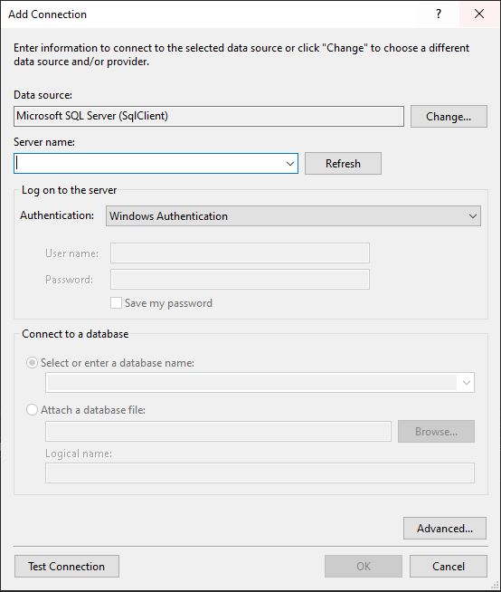
- Under the ‘Tools’ tab in the toolbar menu, select ‘Connect to Server…’.
- Enter the name or the IP address of the machine with your database.
- Under the ‘Tools’ tab in the toolbar menu, select ‘Connect to Database…’. This should display a window such as this:
- Select ‘Microsoft SQL Server (SqlClient)’ as your data source.
- Select the name of your database server which you added in step 3
- If you are working on the same machine from which you are establishing the connection to and you have administrative rights, you may use ‘Windows Authentication’. Otherwise choose ‘SQL Server Authentication’ and provide credentials with administrative rights.
- Select the database you would like to test.
- Test your connection and Press ‘OK’ if your connection worked, otherwise troubleshoot accordingly.
- Repeat steps 2 – 9 for the target database.
At this point you should have created connections to both servers and should be ready to start comparing the two databases.
- Under the ‘Tools’ tab, go to ‘SQL Server’ and select ‘New Data Comparison’.
- This should prompt a window like this:
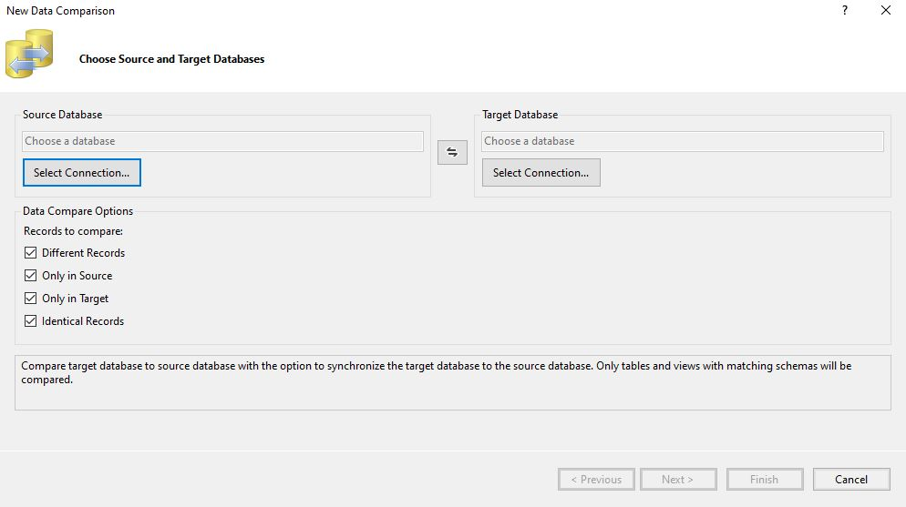
- Select your source connection and target connection respectively by
- Clicking on the ‘Select Connection…’.
- Click ‘Next’ and then select the SQL object you would like to take into consideration during your comparison.
- Click ‘Finish’.
Once SSDT has completed executing the comparison, you should have a view like the following:

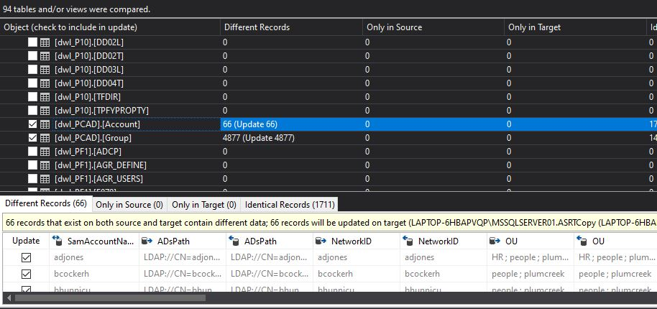

From analyzing this result, you should be able to derive data inconsistencies and accuracy. The following section will cover how you can synchronize your data to eliminate these inconsistencies.
Data Synchronization:
After you’re done inspecting the records which are missing at the target database, you can synchronize those records by using the details pane:

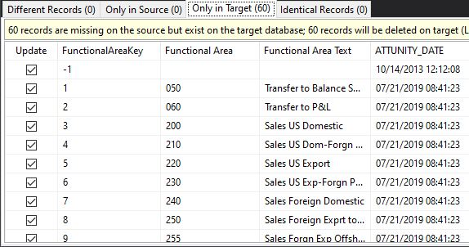

Every record which needs to be synchronized should be selected in the ‘Update’ column on the left-hand side. Depending on the size of the T-SQL file you can either click ‘Generate Script…’ or from the toolbar menu under ‘SQL’, select ‘Export to File…’.

Since we are only trying to migrate records from the source to the target and not the other way around, you should only select records in the ‘Only in Source’ tab. Additionally, the T-SQL script that SSDT creates will delete the records from the source database; if you wish to avoid deleting records from the source database at this point, you can remove any DELETE statement from the script.

Other Data Comparison Tools:
There are other tools that you might want to check out if SQL Server Data Tools does not have a feature you would like to use during your migration assessment. Some third-party tools that you can look further into are included in the following chart.
Product Name | Operating System | Data Synchronization | Schema Compare | Schema Sync | Free Tier Availability
QuerySurge | Windows | Yes | Yes | Yes | No
Red Gate SQL Compare | Windows | Yes | No | No | No
SQL Data Examiner | Windows | Yes | No | No | No
dbForge Data Compare for SQL Server | Windows | Yes | No | No | No
DB Ghost Change Manage Professional | Windows | Yes | Yes | Yes | No
MssqlMerge | Windows | Yes | Yes | Yes | Yes

Optimization
Beyond assessing data accuracy and completeness, you should find any underlying performance issues that might have been introduced in the migration. Optimization might include the following steps:
- Assess what new features may be available on the target platform: New features that were previously too complex or cost inhibitive to warrant implementation on-premises may now be available via a few clicks in the Azure Portal. These features should be considered as to whether they would bring good benefits to each workload and then should be implemented as appropriate.
- Re-structure workloads into more cost effective or performance effective sets: This might include allocating databases that make up a workload into various service levels and performance tiers on Azure SQL Database. These were previously lumped together on the same on-premises SQL Server due to hardware and licensing costs, but with the fully managed service offering of Azure SQL Database it’s now cost effective to grant individual databases additional resources if beneficial.
- Ensure workloads are right-sized: Look to realign workloads into the more appropriate service levels and performance tiers. Previously they shared a combined pool of compute and storage resources on the physical server where they resided that was underutilized to allow for future growth. Now with the fully managed service offering of Azure SQL Database it’s possible to get a more accurate size of the databases by using tools such as the Azure SQL Database DTU calculator or comparing on-premises core requirements to vCores and dial up the allocated resources only if required.

Below are some recommendations for best performance during the migration process:
- Choose the highest service level and performance tier that your budget allows for the migration time to maximize the transfer performance: While migrating, the database will be performing an enormous quantity of write operations and by under-sizing the selected performance tier you may unintentionally throttle the throughput, causing a much-extended migration timeline. Instead, choose a higher performance tier than needed temporarily during the migration, and then scale back down after the migration to minimize costs.
- Minimize the distance between your BACPAC file and the destination data center: By minimizing the physical distance between your BACPAC file and the destination data center, the network latency will be reduced. This in turn will increase overall migration throughput as more read and write operations to the target database can be completed in the same period.
- Disable auto-statistics during migration: On Azure SQL Database, statistics objects have “Auto update” turned on by default. The auto update of the statistics is done when a sufficient amount of change to a table has occurred. During the import process, when nearly all the rows in all tables are changing, this trigger is repeatedly met, causing continuous attempts to update the statistics. This update uses valuable IO resources to complete, which detracts from the overall pool of IO resources available for the import process and extends the migration timeline.
- Partition tables and indexes: Partition tables and indexes can help with the transfer and access of data during a migration. The data can be partitioned into one or more subsets that are similar and will allow for the transfer of data quicker. Partitioning large datasets can also reduce lock contention, because lock escalation can be activated at the partition level without hurting the entire dataset. Once the data is moved to the cloud, then queries may performance faster and reduce overhead costs for applications. Overall partitioning tables and indexes helps the migration cost and mitigates future risk after the migration by helping increase performance of the data.
- Drop indexed views and recreate them once finished: When an indexed view is used, every time data is modified on an underlying table Azure SQL maintains the index entries on those tables, but also the index entries on the view. This can affect write performance and again reduce IO resources available for the import process, extending the migration timeline. In addition, they also have the potential to cause other issues such as lock contentions.
- Remove rarely queried historical data to another database and migrate this historical data to a separate Azure SQL Database. You can then query this historical data using elastic queries: By purging historical data from a database, the size of the database and thus the amount of data needing to be migrated can be drastically reduced. This helps meet tight maintenance window targets as the core data can be moved to Azure SQL in a much shorter time, enabling the application to be brought back online sooner. The rarely queried historical data can be migrated in a less aggressive timeframe given it is a much lower priority.

Below section will cover some common performance issues and how you can debug them.

Query Regressions due to change in CE Version
If you have migrated from a SQL Server version older than 2014 and you have adjusted your database compatibility level to the latest version, there is a high risk that you’ll have performance regression. This is because since SQL Server 2014, all Query Optimizer changes are correlated with the latest database compatibility level. The purpose of this change was to give database users greater control over query performance when performing an upgrade.

You can learn more about this in the following document:
https://docs.microsoft.com/en-us/previousversions/dn673537(v=msdn.10)?redirectedfrom=MSDN

Solution
To resolve this issue, you should first change your database compatibility level back to the source database version and then you can follow the following steps to optimize your query performance:
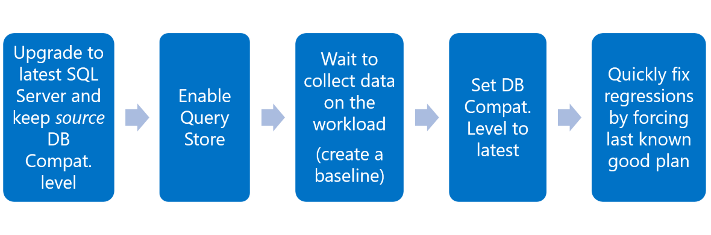
Missing Indexes
When executing queries, stored procedures, and views; SQL performs caching to speed up performance any time the same action is recalled. In the migrated database, this caching of execution plans will not be available at first and will cause execution delays. To minimize this impact, you can follow these steps:
- Use the RECOMPILE hint. A plan is calculated every time adapted to each parameter value.
- Edit your stored procedures to use (OPTIMIZE FOR (<input parameter> = <value>)). Depending on the workload, you will have to choose a value for creating and maintaining one plan that becomes efficient for parameterized values.
- Rewrite the stored procedure using local variable inside the procedure. Now the optimizer uses the density vector for estimations, resulting in the same plan regardless of the parameter value.
- Alternatively, you can edit your stored procedures to use (OPTIMIZE FOR UNKNOWN), which would have the same outcome as using the local variable technique.
- Rewrite your queries to use “DISABLE_PARAMETER_SNIFFING”. This would also have the same effect as using the local variable technique, unless “OPTION(RECOMPILE)”, “WITH RECOMPILE”, or “OPTIMIZE FOR <value>” are used.

Additional Post Migration Validation and Optimization Documents
For additional details about these issues and specific steps to mitigate them, see the following resources:
- The Post-migration Validation and Optimization Guide
- The article Tuning performance in Azure SQL Database

Additional Resources
Following are details of Additional Resources:
- SQL migration using Azure Data Migration Service (DMS) hands-on lab.
- Be sure to check out the Azure Total Cost of Ownership (TCO) Calculator to help estimate the cost savings you can realize by migrating your workloads to Azure.
- For a matrix of the Microsoft and third-party services and tools that are available to assist you with various database and data migration scenarios as well as specialty tasks, see the article Service and tools for data migration.
- For options related to migrating Azure SQL Database to a managed instance, see the blog post How to Migrate Azure SQL Database to Azure SQL Managed Instance.

Videos
- For an overview of the Azure Database Migration Guide and the information it contains, see the video How to Use the Database Migration Guide.
- For a walkthrough of the phases of the migration process and detail about the specific tools and services recommended to perform assessment and migration, see the video Overview of the migration journey and the tools/services recommended for performing assessment and migration.
- For details about the pre-requirements, including Azure VNet and firewall configuration needed to create a DMS instance, see the video How to address pre-requisites and create an instance of the Azure Database Migration Service.
- For information about how to monitor an online migration and perform a migration cutover when the initial load and data sync have completed, see the video How to monitor an online migration and perform migration cutover.

